**1. Choose a question**

Can show the class can lead student to graduate.

**2. Identify the needed data and comparisons**

Sometimes, student will always take the class they like, so they will miss some important class that cause them cannot graduate successfully.

What the graduate process is?

What the challenge level this course, if this is too difficult to affect graduate

What the track of major you want to go?

**3. Identify data source.**

1. **Mycuinfo track graduate**
2. **FCQ (the difficult of this course)**
3. **The introduction of this course**
4. **The track of major**

**4.Create a thumbnail sketch of your visualization and search page.**

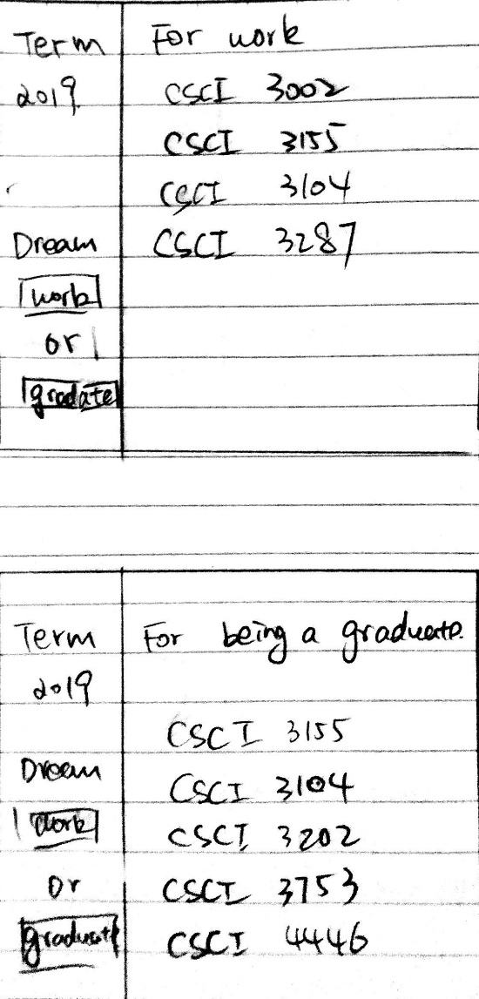

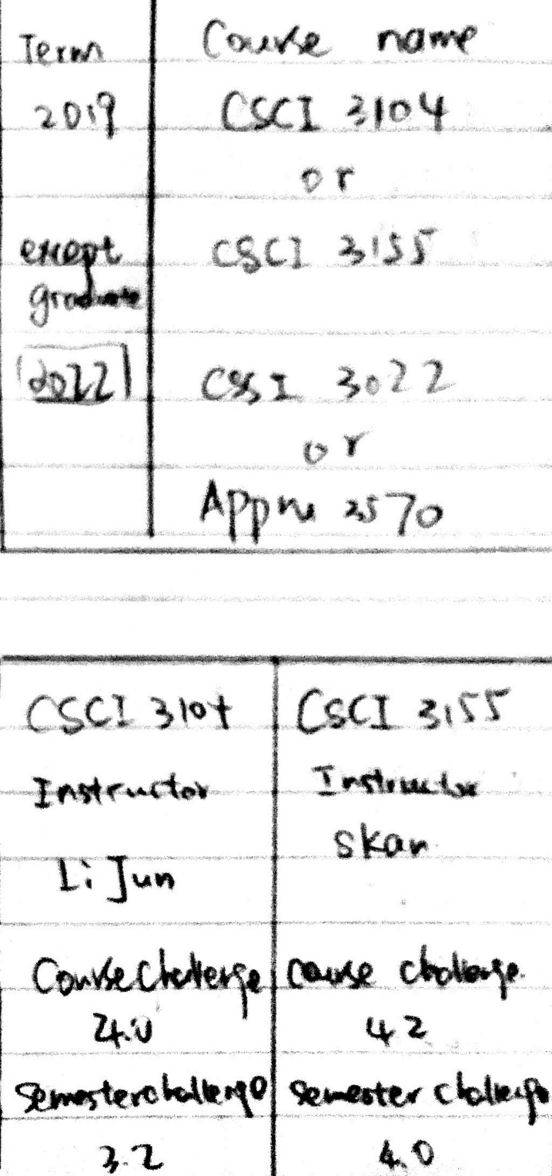

Difference: For the first prototype of a student service like the Arts Science class, they will miss their main course. These effects can cause students to not graduate properly. For the second prototype, this group of students prefers to graduate more easily. They can choose to go to class more easily.

Advantage: For the first prototype, students can know which course is necessary during the graduation process. Students can avoid complicated processes (open mycuinfo, click track, and then run my audit) some freshman and don't even know about this option. For the second prototype, students can analyze their dreams, and everyone knows that there are more challenges to becoming graduate students. So they can choose to go to class more easily.

Disadvantages: Both types of prototypes are more focused on a large group of people. Some students may not belong to any type. This search system is very difficult for them.